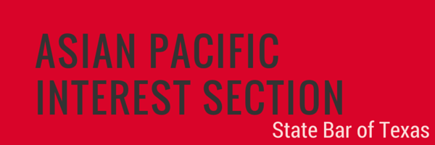

NOMINATION FORM
BEST LAWYERS UNDER 40 AWARD

The Asian Pacific Interest Section (APIS) Best Lawyers Under 40 Award recognizes talented individuals within the Asian Pacific American (APA) legal community under the age of 40 who have achieved prominence and distinction in their fields — be it the practice of law, academia, business, civic and charitable affairs, the judiciary, or politics — and have demonstrated a strong commitment to civic or community affairs.

Nominees must be licensed to practice law in Texas, have paid membership dues prescribed by the Supreme Court of Texas, be members in good standing of the State Bar, and be under the age of 40 as of January 1, 2019. It is highly preferred that the Nominee be present at the APIS Conference Awards Ceremony to receive the award.

Nominator Information
Name: Relationship to Nominee:
Firm, Company, or Organization: Title:
Address:
Phone: Email:

Nominee Information
Name: TX Bar Number:
Firm, Company, or Organization: Title:
Address:
Phone: Email:

Please use additional pages to answer the following questions. The nomination package shall be strictly limited to no more than 8 total pages, including this form and all supporting documentation.

- Background Information: provide background information concerning the nominee’s career.

- Career Achievements: provide details of nominee’s demonstrated success and professionalism in the practice of law.

- Commitment to the APA Community: provide details of nominee’s civic and community activities.

- Other Relevant Information: additional information and supporting materials, such as letters of support, curriculum vitae, or resumé, are welcome but not required.

Nomination must be received no later than 5:00 p.m., Thursday, January 31, 2019. Submit the application and any supporting materials to: Jim Thomas at thomas@fyiplaw.com. All submissions will be acknowledged with a reply. The award will be presented at the Awards Ceremony on Friday, April 26, 2019 at the Hyatt Regency in Austin, Texas, in conjunction with the 2019 Annual APIS Conference. We request that award winner be available to attend the Awards Ceremony.

